Denise Penizzotto
HAA 96 Whose Culture Is It?
October 5, 2021

The photography of Francis Frith and Nelly (Elli Sougioultzoglou-Seraidari)
Thought: The photograph is a social document. It represents a relationship between the photographer and its subject, with the power of manipulation falling in the hands of the photographer to create a specific narrative. The work of Francis Frith and that of Nelly are two prime examples of this point; using the same location, Nelly and Frith give the viewer opposing impressions of the Greek outline.
Photographer Francis Frith, British (Chesterfield, Derbyshire, England 1822 - 1898 Reigate, England) https://hvrd.art/o/143703

Date
1860s
Technique
Albumen silver print
Dimensions
image: 15.7 x 20.7 cm (6 3/16 x 8 1/8 in.)
mount: 25.8 x 35 cm (10 3/16 x 13 3/4 in.)
Credit Line
Harvard Art Museums/Fogg Museum, Transfer from the Carpenter Center for the Visual Arts, Transferred from Widener Library
Accession Year
2011
Object Number
2.2002.306
Division
European and American Art

Scene of the ruins of the Acropolis and Parthenon showing the remains of the temple and Doric columns.

Francis Frith’s photographs of the Parthenon emphasize the ancient architectural past through a lens of distance removal. Through his “uphill angle” technique, he creates the gaze of one who is distanced and removed from this glorious past, yet, via his choice of centering the Parthenon within the photo and utilizing the site path as a visual entrance point, he invites one into the field of rubble and upward to encounter this majestic site. The viewer gets a romanticized sense of loneliness and loss for a period of great glory.

Frith photographed the Acropolis’ Parthenon ruins without the presence of people or any item of modernity, creating a sensorial experience for the visitor of a distanced and lost era. As a viewer we have no indication of modern life and are left to believe the life of Greece is in the past.

Francis Frith was a British citizen who used his success in photography to establish F. Frith & Co., a print company that specialized in postcards of landscape and architectural views. Noting that his audience was primarily of British decent, the omission of a modern and prosperous Greek gave way for the argument that Greece could not care for its antiquities thereby giving providence to items such as the Parthenon Marbles to the British.

People
Francis Frith, British (Chesterfield, Derbyshire, England 1822 - 1898 Reigate, England)
Title
The Erechtheum, Athens
Object Number
2.2002.301
Classification
Photographs
Work Type
photograph
Date
1860s
Persistent Link
https://hvrd.art/o/143285
Physical Descriptions
Technique
Albumen silver print
Dimensions
image: 15.4 x 20.9 cm (6 1/16 x 8 1/4 in.)
mount: 25.6 x 35.6 cm (10 1/16 x 14 in.)
Acquisition and Rights
Credit Line
Harvard Art Museums/Fogg Museum, Transfer from the Carpenter Center for the Visual Arts, Transferred from Widener Library
Accession Year
2011

The Erechtheum, Athens. This Temple, dedicated to Minerva Polias, was built on the spot where Neptune and Minerva are said to have contended for the soil of Attica.

In this photo by Frith, the gaze is again viewed from below. He utilizes the uphill view as a technique to engage the viewer as if in a climb towards the subject, yet there is an emptiness to this angle that keeps a distance between viewer and subject. By reducing the field of rubble between the viewer and the subject Frith has provided a sense of close observation of the ancient past. We do not see any items of modernity in the foreground or background of this photo, leaving the viewer to believe the Erechtheum has been lost in time. The Caryatids are photographed looking outward, away from the gaze of the viewer as if in a world of their own, enforcing the distance between the ancient past from the modern day.

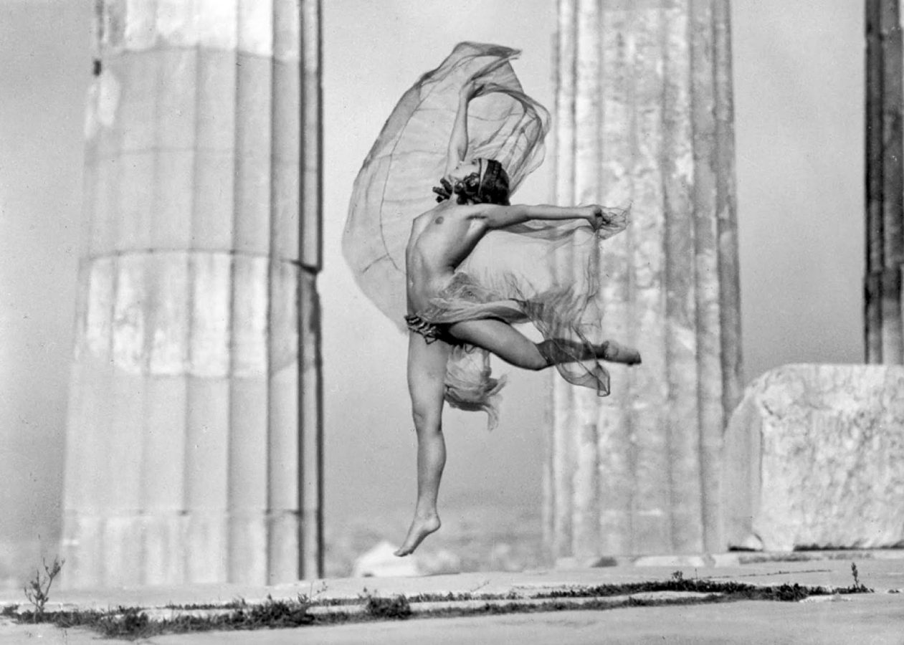
The Hungarian dancer Nikolska in the Parthenon, 1929. Photo: Sougioultzoglou-Seraidari Elli (Nelly’s). © Photographic archives of the Benaki Museum.

Artist and photographer Elli Sougioultzoglou-Seraidari, known as Nelly, was commissioned by the Greek Archaeological Service in the early 20th century to Greek antiquities, the architecture and sculptures. The photographic images Nelly created during this period moved beyond that of a straightforward record of Greek history through her creative eye, imbuing the photos with a dramatic flair of light and dark shadows, sharp vertical and horizontal axes and camera angles that captured the life of these objects, rather than the staid existence of ancient artifacts previously recorded by earlier photographers.

Nelly studied photography in Germany under the tutelage of Hugo Erfurth, a renowned portrait photographer of celebrities and cultural figures. Nelly too became a portrait photographer after her move back to Greece in 1924; her portrait work of the Greek bourgeoisie became status symbol for the self-appointed culturally elite. Eventually combining her two subjects Nelly moved away from the form of landscape documentation and portraiture. She introduced models and performers into her photographs of the Greek landscape, bringing new life to the Greek landscape as part of an active scene. In combining the national ancient treasures of Greece with performance she created a new narrative for a modern emerging nation. This work brought her to new artistic heights.

The result of these photographs was multi-temporal; in using contemporary models and dancers she captured the potential of her times simultaneously giving agency to the spirit of the classical ruins. More than an evidential photographer, she brought her artistic eye and creative sensibility to her scenes. Her theatrical atmospheres were created using dramatic lighting, framing her subjects in poses of the ancient gods standing amidst the ruins of their time. Her images do not simply rely on the beauty of the past, through her artistic eye she brings an element of modernity into the work.

An example of this dynamism can be seen in the photographs of Nikolska, the Hungarian dancer who Nelly photographed on the steps of the Acropolis, naked except for her jewelry and gossamer scarf. Nelly captured Nikolska in her graceful dance, mid-air between the columns of the Parthenon. The translucent fabric she holds is captured by the wind giving the viewer the impression of flight, lifting Nikolska effortlessly off the ground. The columns of the Parthenon take on a transparent air as if they have become weightless, filled with the spirit of the moment. One can sense the movement of the air that is captured in this image.

Nelly’s choice to photograph her subjects nude on the Parthenon grounds did not escape controversy from a more conservative Athenian society however this controversy was short lived part in due to a substantial argument (perhaps misconceived but a useful trope non the less) by her supporter Pavolos Nirvanas, the honored Greek poet and critic. Pavolos declared that the Olympian deities were worshipped naked in their temples to no outcry of sacrilege, so be it today. Nelly continued photographing naked athletes and dancers on the Acropolis and in other ancient sites in her love of her homeland’s past. Her photographs of Greek’s people alongside the ancient Greek statues sends message of the historical lineage the modern Greek as to its ancient past.
Her photographs became associated for some with the Greek ideology of the ancient past lineage as a pure, unbroken race, bringing Nelly into the center of a Greek Nationality propaganda campaign, an association that may not have been an accurate association with her artistic vision. She decorated the New York International Expo of 1939 with her photographs and collages, understood by some to be presentation of the Hellenism continuity, still unclear today if this was Nelly’s intended message; she does not deny or acknowledge this claim in her autobiography. Whether Nelly proceeded in this propaganda platform because of her personal interests or in determination to remain relevant, it must be recognized that Nelly’s quest for beauty in all things, be they of the human figure or her surrounding landscape is what moved her to create her timeless images.

